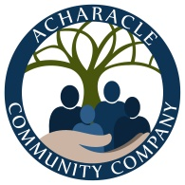
Directors Meeting 3rd March 2021
meeting number 21 - 03

Minutes

Present
In person by Zoom: Marie-Luise MacDonald (Chair - MLM) / David John Cameron (DJC) / David Kirkham (DK) / Fiona Cameron (FC)
In attendance by Zoom Becky Dacre (BD – minutes & notes)
Apologies: Rodney George (RG) / Angela Williams (AW) / Lesley MacMaster (LM)
Trustees are reminded that this meeting is confidential and may only be recorded with the consent of the chair and in the full knowledge of all participating parties. Any such recordings must be destroyed when no longer required to serve the sole interests of the charity.(Quorum of 3 trustee directors)

Nr |  | Item | lead
 |  | Approval of minutes & notes of last meeting(s) | Chair
 |  | The confidential record of meeting 21 02 and formal minutes were approved for publication
 |  | Matters arising & not dealt with below | Chair
 |  | The board learned with regret the suspension of De tha dol? They are holding a Public Meeting 31st March to discuss future of the publication.
 |  | Financial report as at  1st March 21 - The board received and noted the following summarised financial report: | DJC
 |  | 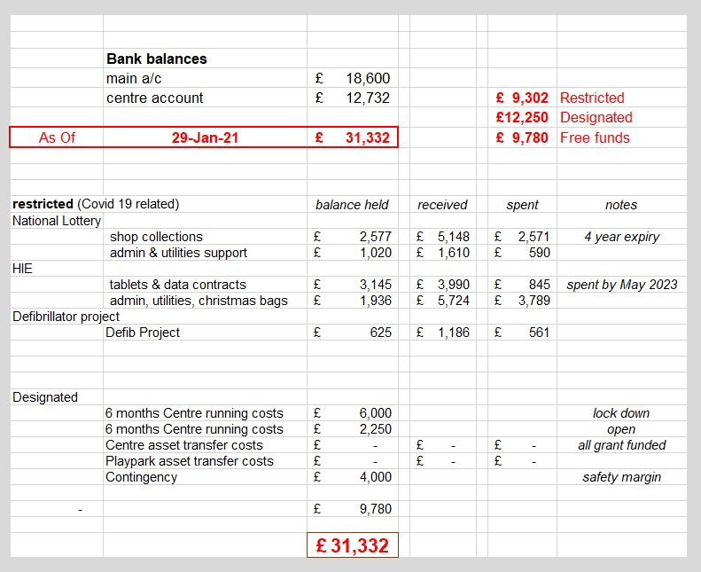
 |  | Correspondence | BD
 |  | Andrew Green correspondence:  The Chair presented a recommended draft response that had been prepared by the G,C & F subcommittee. After consideration, the draft was unanimously approved, and the Administrator was instructed to respond in the agreed terms (appended herewith). | BD
 |  | Membership applications/changes / board & officer appointments | BD
Approval of new ordinary member: Chris Halliday
Play park committee and new members: Kirsten Macleod / Yasmin Findlay – approved. Awaiting completed membership forms.
 |  | Company Secretary: DK has been notified of the appointment with Companies House as Company Secretary (dated 20.2.20) and will resign at 31.3.21 as agreed at the previous board meeting. The need for Company Secretary will be removed from the Memorandum which is currently being re-drafted by DK.
Appointment of new Trustee/Directors: Mia Berwick. Approved as ordinary member (upon receipt of completed membership form). Approved as co-opted director. To be re-elected at AGM
Tracy Cameron Approved as new trustee/director (a current member). To be re-elected at AGM
Asset management - Investment Properties – café, Na’vi & house and Community Garden
No activity to note
 |  | Asset transfer – progress with the pre-approved asset transfer. | Chair
Progress with the pre-approved asset transfer by Highland Council and associated funding
Draft HC agreement received and changes to be made: change wording from ‘day care centre’ / requesting EDB of max 5 years. Date for final draft to be end of March / April. Awaiting documents from HC for building maintenance (wiring / asbestos report).
 |  | Nature and timing of presentation to be submitted to the members when seeking approval including operational budget for the first 12 months after transfer. MLM/FC/DJC working on it.
Consideration of associated publicity and support-generating initiatives:
FC – suggested video / tour of building / compiled with info too /date of vote etc for Fb/website. To be worked on by FC/MLM/DJC.
 |  | Project Worker post: Applications - 1 received / 4 have asked for further info. Timing & detail of interviews to be arranged. Dependent on applications received. Similar system for interviews to be used as previously. AW offered help with interviews although not present at this meeting.
 |  | Subcommittee Reports
 | A | Compliance, Governance & Financial | DK
Company Secretary –
After further investigation it has been discovered that at a board meeting on 20.2.20 the board resolved to appoint David Kirkham to that position but notification to Companies House was overlooked by both him and the Board until recently. To be eligible to become our pro-bono Independent Examiner for the 2022 year onwards he will therefore resign as director and as company secretary on 31st March 2021. Since the Company Secretary has no practical role or function with this charity it is proposed to leave the position unfilled and to abolish it at the next revision of our Memorandum of Association.
 |  | Accounts – Companies House have fully approved accounts. Signed copy in Dropbox. BD to file with CH.
 | B | Community Centre Operations | DJC
Progress report including building maintenance & reuse project.
DJC hoping centre will open in June. DJC / Project Worker to work on renovations.
 | C | Play Park project | FC
Progress with the pre-approved asset transfer by Highland Council and associated funding
FC – Asking Scotplay for another design option to use for consultation with school.
BD to liaise with FC about insurance for play park.
 |  | Nature and timing of presentation to be submitted to the members when seeking approval including explanation of the lack of any operational budget for the first 12 months after transfer.
Consideration of associated publicity and support-generating initiatives.
Fund raising on hold until members approval of asset transfer.
 |  | Project – defibrillator
The new PAD has been installed outside Café Tioram and has been registered for use with ’The Circuit’ and is now live. Notices have been posted around the village showing its location. The tenants of the Café have agreed to check the defib according to information provided by BD. Any problems and re-ordering of certain items like batteries / pads etc will be done and paid for by ACC.
BD to post on Fb with ‘Thank you’ for all donors. BD to get price from All round signs for more permanent notices.
 |  | Grants & Charity Fund raising - consideration of offers of donations to the charity (if any) & inviting Gift Aid donations: Nothing to note. | AW
Member General Meeting – further consideration of draft notices
MLM/DJC/FC to write notices for AGM
Date fixed for AGM/EGM – Thursday 30th at 7.30pm. 2 weeks notice must be given. All notices to be posted by 13th. To advise SLF when vote will be.
Risk evaluation & monitoring
The Board considered that there were no material changes in the circumstances in which the charity is operating and that the current policies remain appropriate and adequate.
 |  | Date of next meeting
 |  | The next meeting was set for 19:30 on 18th March and this meeting closed at 9.07pm

documents to append:
Email to Mr Green:
Dear Mr Green,
Your correspondence (including the additional two that you sent just before our February meeting) were considered by the board yesterday. I am instructed to write to you in the following terms:
You are clearly experienced enough to know that this Board's obligations are jointly to the whole community and to the charity’s OSCR regulator - not to any single member of the public, however assertive, determined or motivated.
The Board has previously drawn to your attention their considered view that the content and persistent nature of what is now an increasingly extensive body of correspondence from you has given them no small concern with regard to the potential effect of this on vulnerable individuals - the trustees, their subcontractors and employees. The Board has been further influenced by learning that several potential new Trustee-Directors have recently declined to serve on this Board unless and until they are comfortable that they would not then become exposed to any unreasonable and unwelcome pressure from you.
The Trustees have reluctantly concluded that the overall impact of your correspondence (and known wider conduct in relation of other community-serving organisations) serves to significantly impair their ability to advance the charitable objectives of this Company.
Accordingly, the Board re-affirms its position that you ceased to be a member by the terms of your email dated 11th October 2020. I am not aware of any internal process within the Memorandum of Association that sets out a basis upon which you might successfully challenge that decision. You should also expect that the current board would not be minded to approve any new membership application from you and, in the event of any re-instatement of your membership being imposed upon them, would call an appropriate meeting of all members under clauses 42 & 55 of the Memorandum of Association to put the matter beyond doubt.
The Trustees will, of course, continue to welcome all helpful submissions of advice from whatever source (including from yourself) - providing that it is accurate in nature, constructive in approach and courteous in its delivery. The Board will acknowledge and note all such comments but does not consider itself obliged to engage in detail with any such communications.

